Front End Bootstrap
- Working with Bootstrap table
- Download Bootstrap from net, it has CSS / IMG / JS folder in it
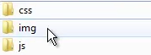
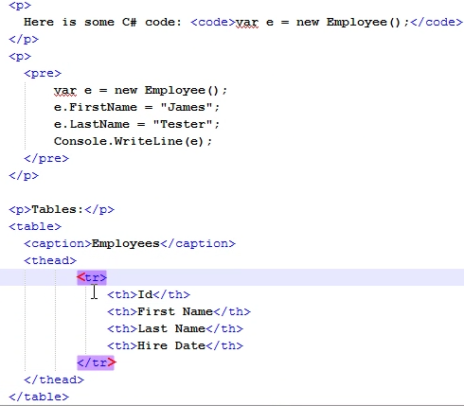
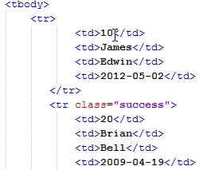

So thead and tbody is used for creating a table using bootstrap.
And output screen looks like
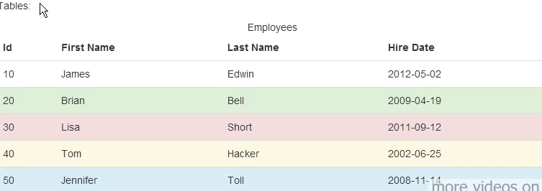
If we modify the table as below
You will see the output screen like below
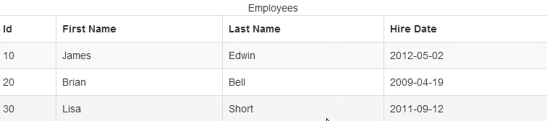

- Working with Bootstrap pagination
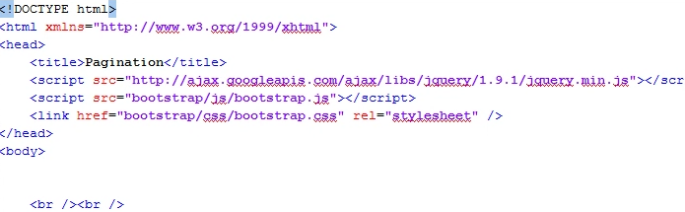
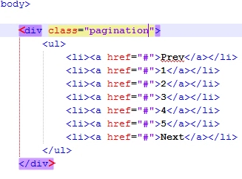
They wil see the output like below :
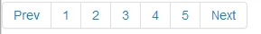
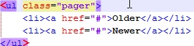


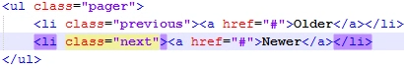

- Working with forms using bootstrap
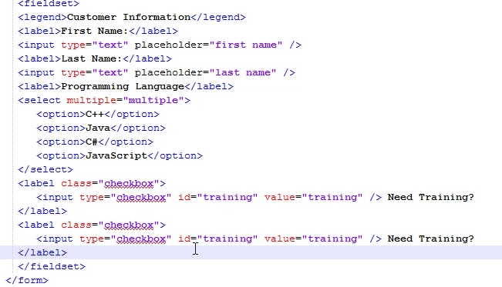
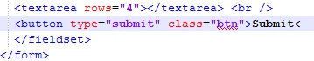

Output of above code like below without any proper structure
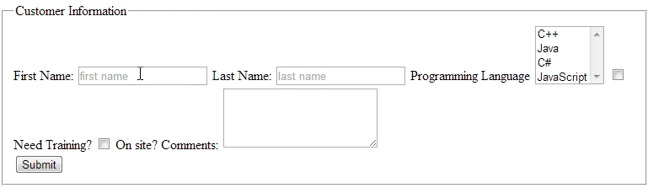

So to make in proper structure we are making or adding following lines
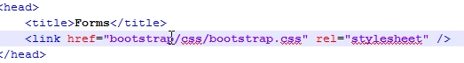
You will scree like below once we add bootstrap details
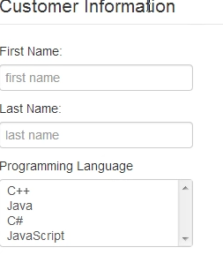

For searching any details using bootstrap
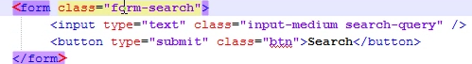

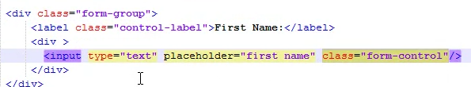

There is no label means you need to use offset like below
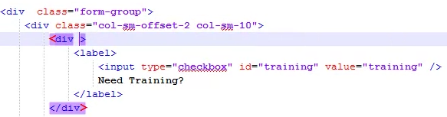

If we use below logic , our screen will be in proper alignment ,
